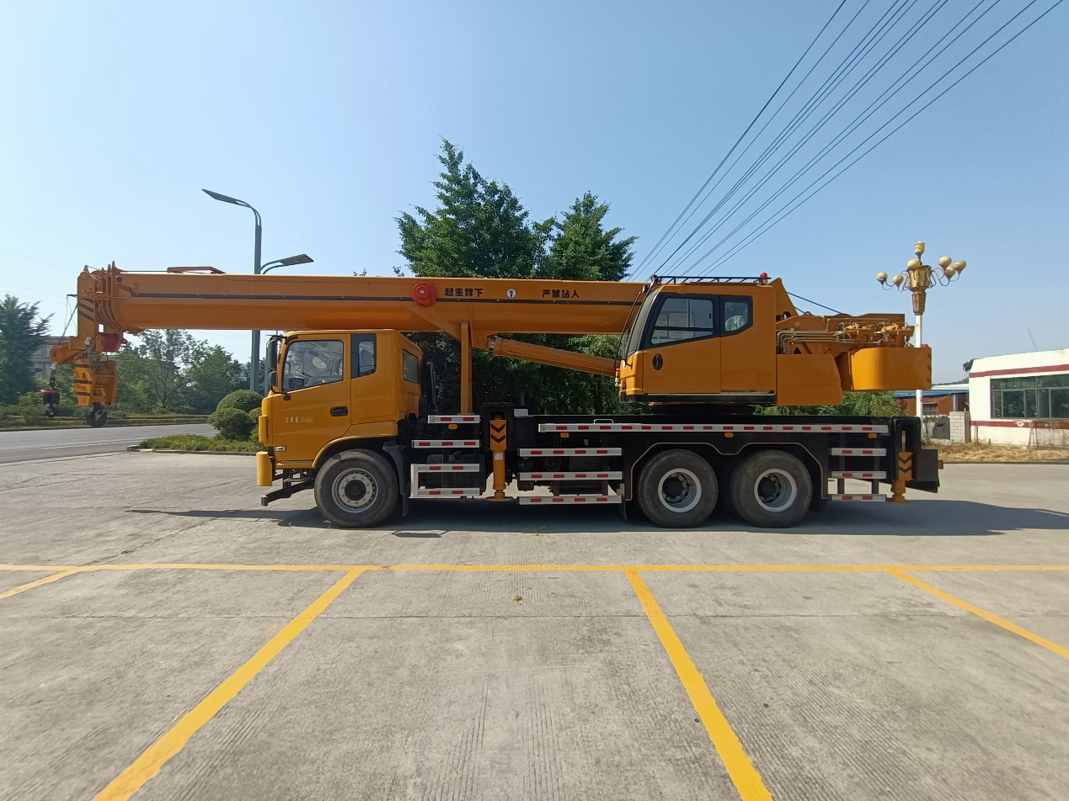

**Main technical parameters table**

The main technical parameters of the driving state table

|  |  |  |  |  |  |  |  |  |  |
| --- | --- | --- | --- | --- | --- | --- | --- | --- | --- |
| form | Item | | | | unit | | Parameters | | |
| Dimensional parameters | Overall length | | | | mm | | 13190 | | |
| Full width | | | | mm | | 2550 | | |
| Overall height | | | | mm | | 3760 | | |
| Weight parameters | Gross mass in traveling condition | | | | kg | | 31495 | | |
| Axle load | | front axle | | kg | | 9000 | | |
| rear axle | | kg | | 11500/11500 | | |
| Power parameters | Engine Model | | | |  | |  | | |
| engine horsepower | | | | Ps | | 240 | | |
| Maximum Climbing Degree | | | | % | | 30，35 | | |
| form | | sports event | | | | | | unit | parameters |
| Main Performance Parameters | | Maximum rated gross lifting capacity | | | | | | t | 30 |
| Minimum rated amplitude | | | | | | m | 5 |
| Turntable tail rotary half warp | | | | | | mm | 3560 |
| Maximum lifting moment | | basic arm | | | | kN.m | 961 |
| longest jib | | | | kN.m | 533 |
| Longest Main Arm + Jib | | | | kN.m | 451 |
| Outrigger distance | | vertically | | | | m | 6.2 |
| orthogonal | | | | m | 7.1 |
| Lifting height | | basic arm | | | | m | 10 |
| full extension of the main arm | | | | m | 39.4 |
| Full Extension Main Arm + Jib | | | | m | 43.5 |
| Lifting arm length | | basic arm | | | | m | 10 |
| longest jib | | | | m | 39.4 |
| Jib mounting angle | | | | | | ° | 0、15、30 |
| Working speed parameters | | Luffing jib luffing time | | | actuating arm | | | s | 68 |
| Jib extension and retraction time | | | allometric | | | s | 150 |
| Maximum rotary speed | | | | | | m/min | 2.5 |
| Outrigger extension time | | Outrigger extension time | | meanwhile | | s | 35 |
| concurrently shrinking | | s | 30 |
| Vertical legs | | meanwhile | | s | 40 |
| concurrently shrinking | | s | 35 |
| Lifting speed (single rope) | | Primary lifting mechanism | | fully loaded | | m/min | 75 |
| unladen | | m/min | 125 |
| Secondary lifting mechanism | | fully loaded | | m/min | 75 |
| unladen | | m/min | 125 |
| off-board radiation | | | | | | dB（A） | ≤122 |
| control room | | | | | | dB（A） | ≤90 |

**Lifting performance table**

(Lifting capacity in kg, boom length and range in m)

Jib lifting performance table

|  |  |  |  |  |  |  |  |
| --- | --- | --- | --- | --- | --- | --- | --- |
| working range | Jib arm length | | | | | | |
| 10m | 14.04m | 17.68m | 23.14m | 28.59m | 34.05m | 39.4m |
| 3 | 30000 | 22000 |  |  |  |  |  |
| 3.5 | 30000 | 19500 |  |  |  |  |  |
| 4 | 22200 | 19000 | 18000 |  |  |  |  |
| 4.5 | 21800 | 18600 | 17100 | 12000 |  |  |  |
| 5 | 19100 | 18200 | 15800 | 12000 | 10400 |  |  |
| 5.5 | 17300 | 17800 | 14800 | 11700 | 9700 |  |  |
| 6 | 15800 | 16100 | 14000 | 11000 | 9400 |  |  |
| 6.5 | 13800 | 14100 | 13000 | 10800 | 8600 | 7200 |  |
| 7 | 12200 | 12800 | 12200 | 10200 | 8350 | 7100 |  |
| 8 | 11000 | 11000 | 10800 | 9200 | 7900 | 6500 |  |
| 9 |  | 9080 | 8900 | 8400 | 7140 | 6050 | 5500 |
| 10 |  | 7430 | 7300 | 7560 | 6510 | 5550 | 5100 |
| 11 |  | 6220 | 6100 | 6700 | 5950 | 5150 | 4700 |
| 12 |  |  | 5100 | 5700 | 5500 | 4700 | 4350 |
| 13 |  |  | 4200 | 4900 | 5100 | 4410 | 4020 |
| 14 |  |  | 3550 | 4200 | 4600 | 4150 | 3800 |
| 15 |  |  |  | 3620 | 4000 | 3900 | 3510 |
| 16 |  |  |  | 3100 | 3500 | 3650 | 3400 |
| 18 |  |  |  | 2300 | 2700 | 2930 | 2880 |
| 20 |  |  |  | 1700 | 2080 | 2300 | 2400 |
| 22 |  |  |  |  | 1580 | 1800 | 1900 |
| 24 |  |  |  |  | 1180 | 1360 | 1500 |
| 26 |  |  |  |  |  | 980 | 1150 |
| 28 |  |  |  |  |  | 700 | 800 |
| 30 |  |  |  |  |  |  | 600 |
| 32 |  |  |  |  |  |  | 500 |